Happy Mother’s Day

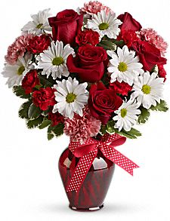

Love,

HZ